

AMERICAN INTERNATIONAL UNIVERSITY–BANGLADESH (AIUB)
Department of Computer Science
Faculty of Science & Technology (FST)
Fall 2024-25
Section: H, Group: 01

PROJECT TITLE

Virtual Classroom Platform: An Interactive, Accessible, and Engaging Online Learning Environment

Supervised By TONNY SHEKHA KAR

Submitted By

Group Members

SN | Name | ID
1 | AFNAN BIN ISLAM NAHIN | 22-49350-3
2 | AMAN ULLAH | 22-49345-3
3 | HRITTIK BHATTACHARJEE | 21-44650-1
4 | MD. HACHIBUR RAHMAN | 22-46426-1
5 | WALID BIN KHALED | 22-46101-1

Lab-2:

Functional Requirements: Virtual Classroom Platform
User Registration

1.1 The platform shall allow new users (students and instructors) to register by entering a username, email, and password.
1.2 The registration process shall require verification via an email link sent to the user's registered email address.
1.3 Once verified, the user shall be able to log into the platform.

Priority Level: High
Precondition: User must have a valid email address.

Course Management

2.1 Instructors shall be able to create, edit, and delete courses on the platform.
2.2 Each course shall have a unique identifier and include fields such as course title, description, schedule, and list of enrolled students.
2.3 Instructors shall be able to add course materials (PDFs, videos, slides) and make them accessible to enrolled students.
Priority Level: High
Precondition: Instructor must be registered and logged in.

Virtual Classroom Sessions

3.1 Instructors shall be able to schedule live sessions for a course, specifying date and time.
3.2 Students shall receive notifications of upcoming live sessions.
3.3 Both instructors and students shall be able to join live sessions, which will support video/audio streaming, screen sharing, and a chat feature.
Priority Level: High
Precondition: Scheduled session must exist, and users must be enrolled in the course.

Assignment Submission

4.1 Instructors shall be able to create assignments, setting a deadline and grading criteria.
4.2 Students shall be able to submit assignments through the platform before the specified deadline.
4.3 Instructors shall have the option to review and grade assignments within the platform.
Priority Level: Medium
Precondition: Assignment must be created, and the student must be enrolled in the course.

Attendance Tracking

5.1 The system shall automatically record attendance for students participating in live sessions.
5.2 Instructors shall have access to view attendance records for each student in a given course.
5.3 The system shall notify students if their attendance falls below a specified threshold.
Priority Level: Medium
Precondition: Student must attend the live session for attendance to be recorded.

Grading and Feedback

6.1 Instructors shall be able to assign grades to students based on assignment performance and attendance.
6.2 The system shall allow instructors to provide written feedback on assignments.
6.3 Students shall have access to view their grades and feedback in their profile.
Priority Level: Medium
Precondition: Student must submit assignments and attend sessions.

User Profile Management

7.1 Each user shall have a profile page showing their personal information, enrolled courses, and grades.
7.2 Users shall be able to edit their profile information, such as email address and password.
7.3 The system shall allow users to view their login activity and manage security settings.
Priority Level: Low
Precondition: User must be logged in.

Notification System

8.1 The platform shall notify users of upcoming sessions, assignment deadlines, and grade updates.
8.2 Users shall have the option to customize their notification preferences.
8.3 Notifications shall be sent via email or in-platform alerts.
Priority Level: Low
Precondition: User must have an active profile with notifications enabled.

Non-Functional Requirements: Virtual Classroom Platform
Usability
- Description: A first-time user should be able to navigate the platform and join a virtual class session within five minutes without additional help.
- Metric: 90% of users should be able to complete their initial tasks (e.g., joining a class, submitting an assignment) without assistance after their first login.
- Priority Level: High
- Precondition: User has access to a compatible device with a stable internet connection.
Performance
- Description: The platform shall support at least 500 concurrent users per session without noticeable degradation in video/audio quality.
- Metric: Response time for accessing any page or feature should be under two seconds under normal load and a maximum of four seconds under peak load.
- Priority Level: High
- Precondition: Server infrastructure and internet bandwidth meet minimum requirements for load handling.
Reliability
- Description: The system should be available 99.5% of the time, excluding scheduled maintenance.
- Metric: System downtime should not exceed 4 hours per month.
- Priority Level: High
- Precondition: Maintenance schedules and disaster recovery plans are implemented.
Scalability
- Description: The platform shall be able to scale to support an increase in users (up to 10,000 concurrent users) without requiring significant redesign.
- Metric: System performance (page load times, video quality) should be maintained within acceptable limits as user count increases.
- Priority Level: Medium
- Precondition: Scalable architecture and cloud-based resources are available.
Security
- Description: All user data, including login credentials and personal information, shall be securely encrypted during transmission and storage.
- Metric: The platform shall comply with industry-standard encryption protocols (e.g., SSL/TLS) and ensure data breaches are minimized to a risk level of less than 1%.
- Priority Level: High
- Precondition: Security policies are implemented and encryption mechanisms are in place.
Compatibility
- Description: The platform should be accessible on major web browsers (e.g., Chrome, Firefox, Safari) and be compatible with mobile devices (iOS and Android).
- Metric: The platform should maintain full functionality on 90% of devices and browsers currently in common use.
- Priority Level: Medium
- Precondition: The latest versions of major browsers and operating systems are supported.
Maintainability
- Description: The platform codebase should be modular to allow future updates and changes without affecting existing functionality.
- Metric: Updates and patches should be deployable with minimal downtime (less than 1 hour) and require no significant code rewrites.
- Priority Level: Medium
- Precondition: Codebase follows modular design principles and is well-documented.
Accessibility
- Description: The platform shall be compliant with accessibility standards (e.g., WCAG 2.1) to support users with disabilities.
- Metric: 95% of all key features (classroom access, assignment submission) should be accessible via screen readers and keyboard navigation.
- Priority Level: High
- Precondition: Accessibility testing and inclusive design standards are integrated into development.

Project Development Constraints: Virtual Classroom Platform
Budget Constraints
- Description: The project must stay within a fixed budget, limiting available resources, tools, and technologies. This may restrict the ability to purchase premium software, hire additional developers, or implement advanced features.
- Priority Level: High
- Precondition: Initial budget assessment and allocation for essential features, resources, and tools.
Time Constraints
- Description: The platform must be developed and launched within a set timeline to meet educational institution schedules (e.g., the start of an academic semester). This may require prioritizing certain features over others to meet deadlines.
- Priority Level: High
- Precondition: Project plan and timeline are established, with key milestones defined for each development phase.
Technology Constraints
- Description: The platform must be compatible with existing infrastructure, such as specific operating systems, browsers, or hardware used by the educational institution. This may limit the choice of technologies and frameworks that can be used for development.
- Priority Level: High
- Precondition: Assessment of educational institution's existing technology environment and compatibility requirements.
Compliance Constraints
- Description: The platform must adhere to industry regulations and standards, such as FERPA (Family Educational Rights and Privacy Act) for student data privacy in the U.S., or GDPR (General Data Protection Regulation) for data protection if serving users in the EU.
- Priority Level: High
- Precondition: Identification of applicable regulations and requirements for compliance, with legal counsel or compliance experts consulted as necessary.
Resource Constraints
- Description: The project team may be limited in terms of available personnel, skills, and expertise. For instance, if there are limited UI/UX designers or cybersecurity experts, certain aspects of the platform may be constrained by available talent.
- Priority Level: Medium
- Precondition: Evaluation of team skills and identification of gaps, with potential recruitment or upskilling options explored as needed.
Scalability and Infrastructure Constraints
- Description: The platform must operate within the available server capacity or cloud infrastructure, which may limit the number of concurrent users and restrict certain features, such as real-time video conferencing.
- Priority Level: Medium
- Precondition: Review of existing server or cloud infrastructure to assess load-handling capacity and scalability.
Security Constraints
- Description: To ensure user data protection, the platform must follow stringent security protocols and encryption standards. This may require additional development time and restrict the use of certain third-party tools or plugins.
- Priority Level: High
- Precondition: Establishment of security policies, with protocols defined for data encryption, secure data storage, and regular security audits.

Lab – 3:
Use case Diagram:

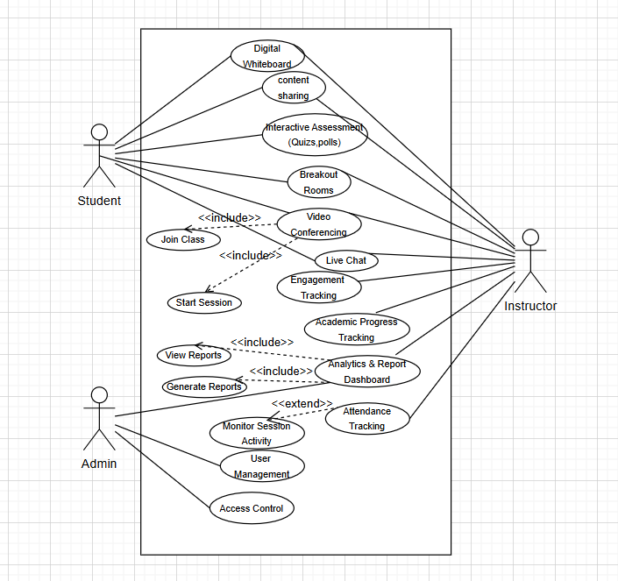

Class Diagram:

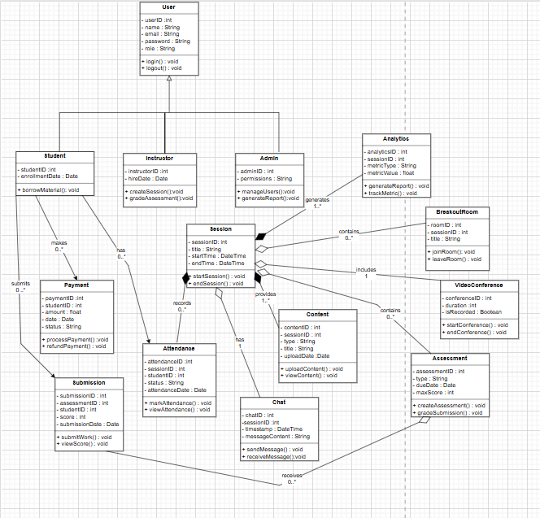

Activity Diagram:

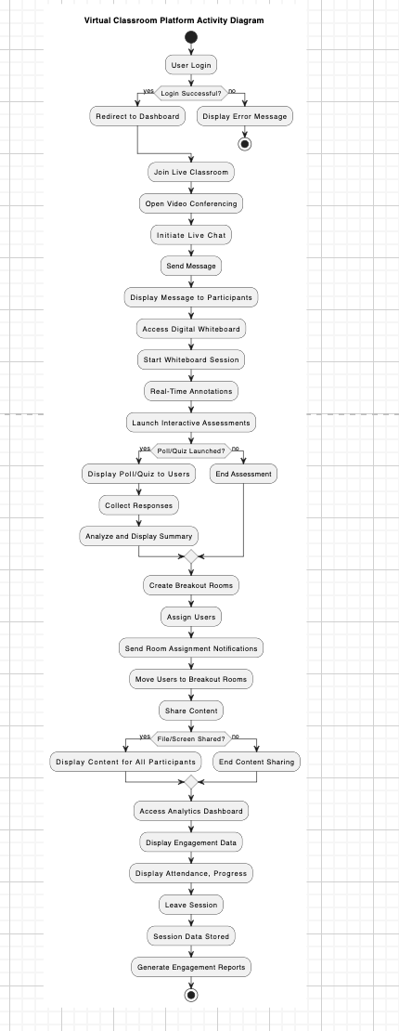

Sequence Diagram:

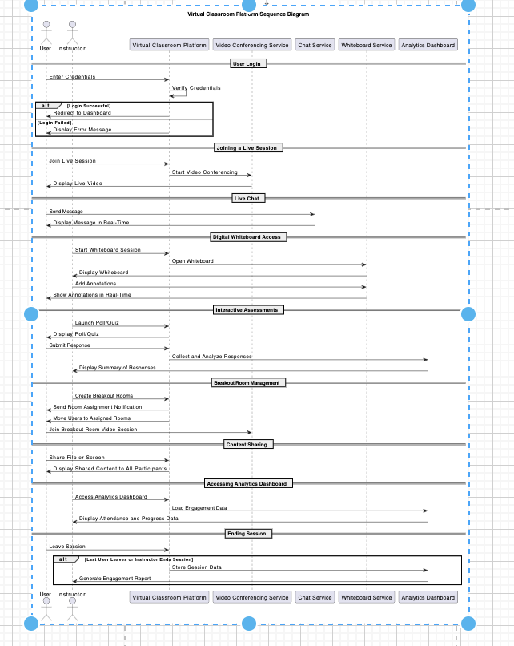

ER- Diagram:

